How to copy sql server database

- Using SQLEXPR_x86_ENU.exe create an empty database first.
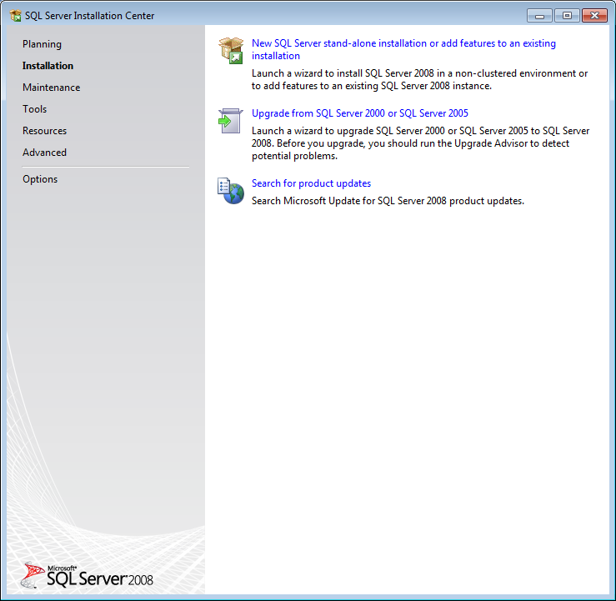
Use “New SQL Server stand-alone installation or…..”option under “Installation”
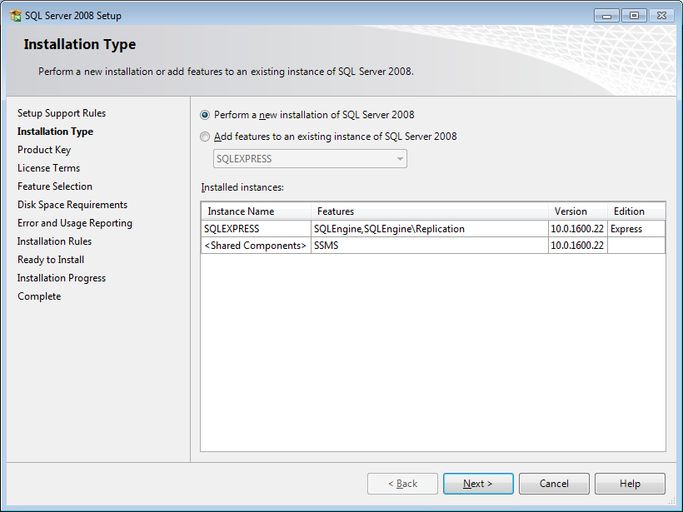

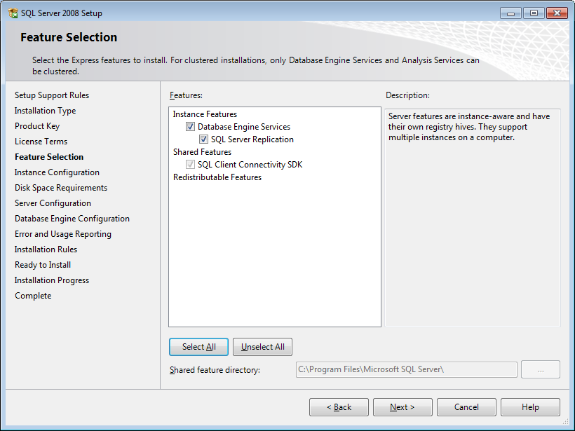
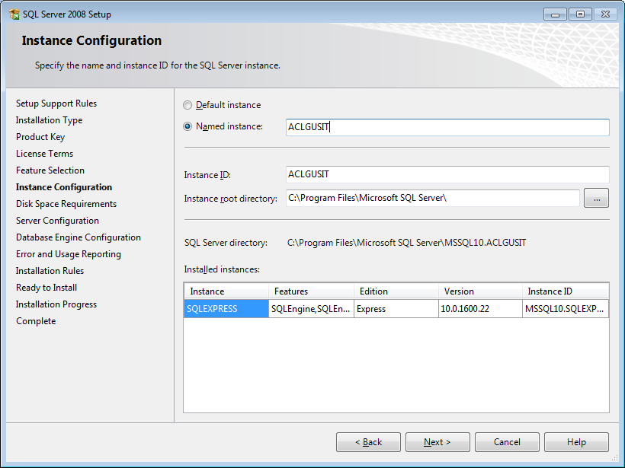
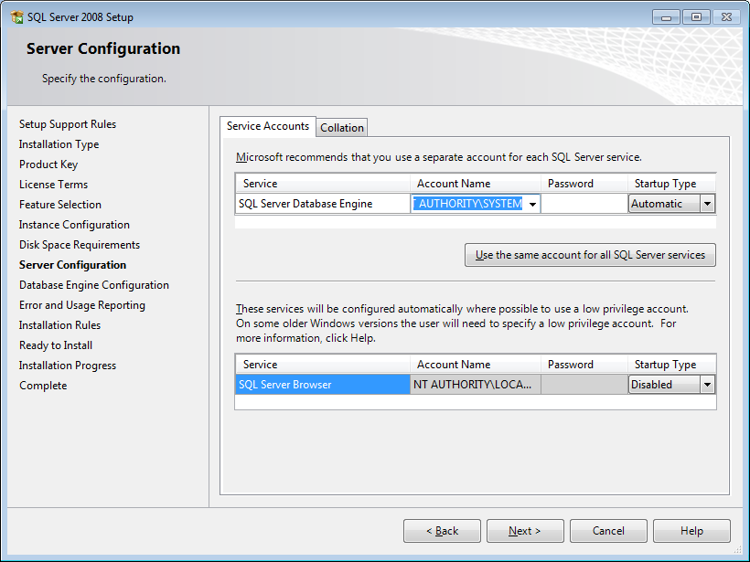
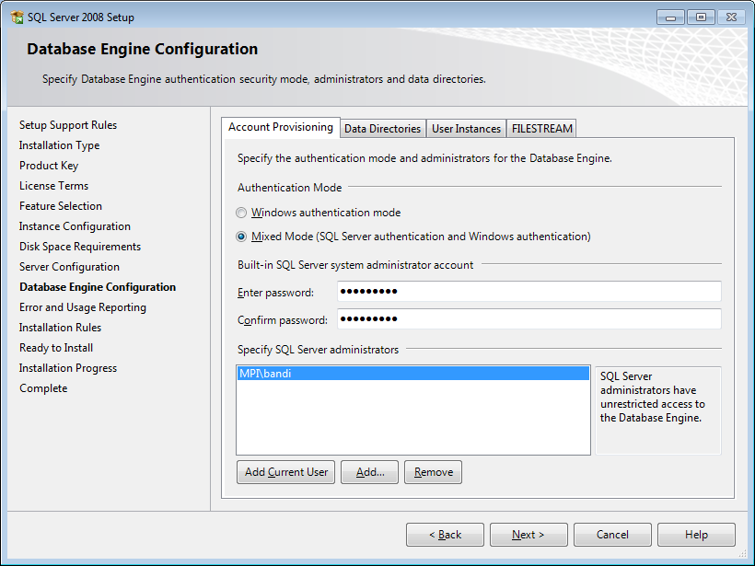
Use “Mixed Mode” and give password for “sa” administrator.

- Use “SQL Server Management Studio” tool to create an empty database under the newly created server.
Log in as “sa” user
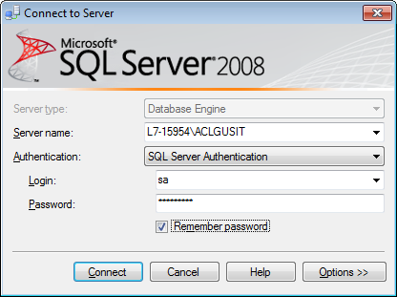
Right click on “Databases” and choose “New database…” option and create an empty database called aclgusit
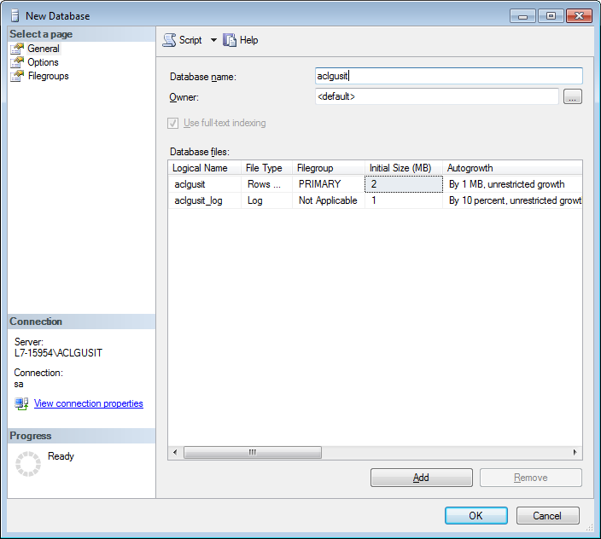

- Use “Import and Export Data (32-bit)” tool
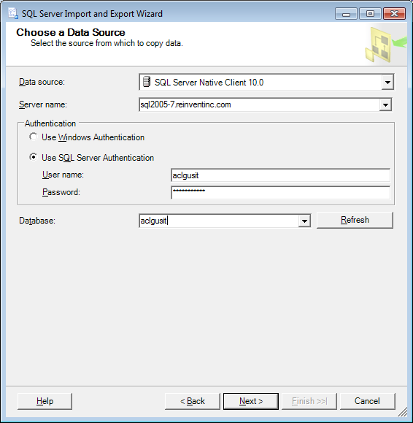
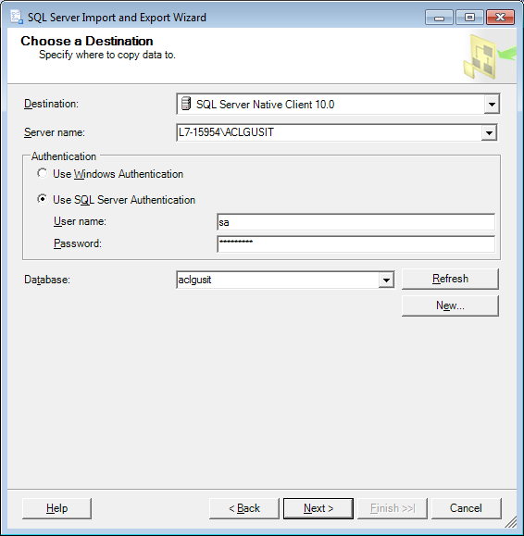
Use “sa” account first.
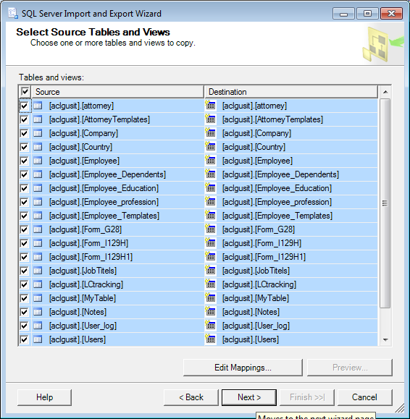
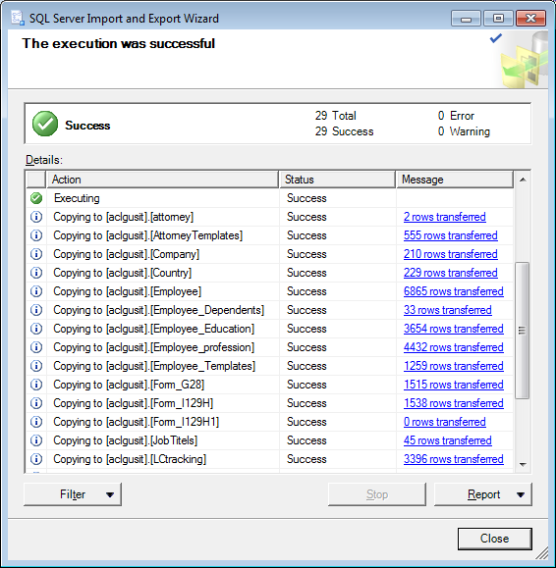

- Use “SQL Server Management Studio” tool to log into newly created server ACLGUSIT using “sa” account to create user login called “aclgusit”
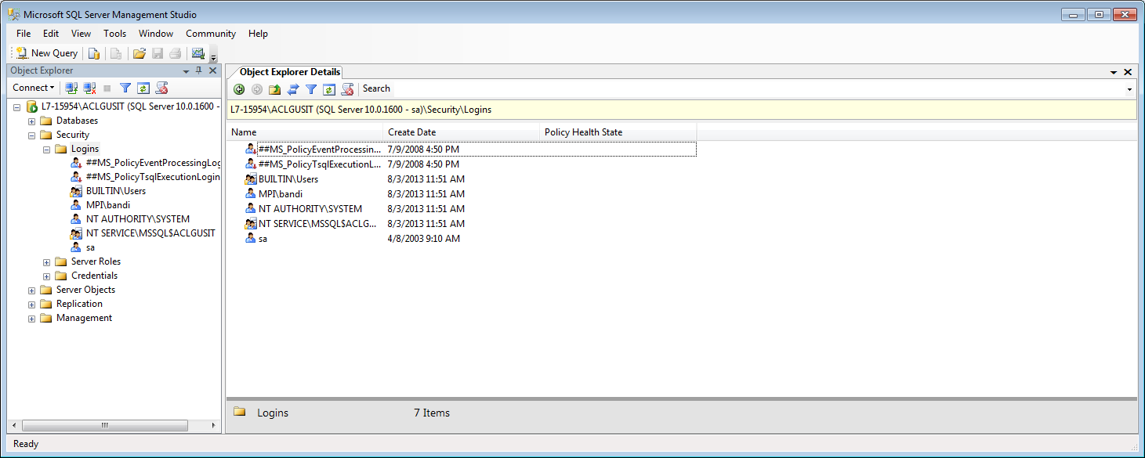
Go to Security -> Login and right click on “New Login….”
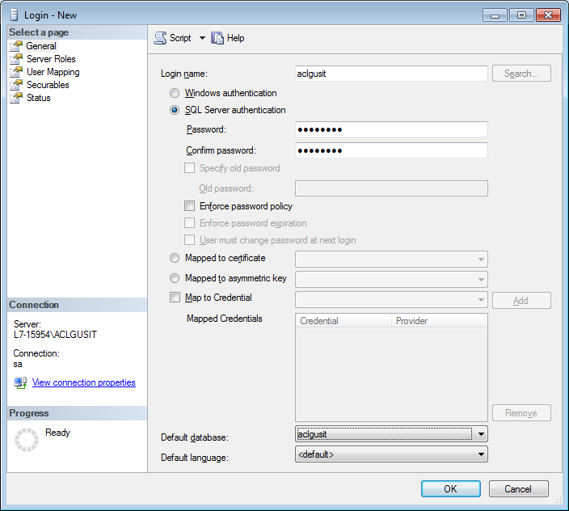
Double click on newly created user and go to “User Mapping” to set aclgusit as default database with dbo_owner role
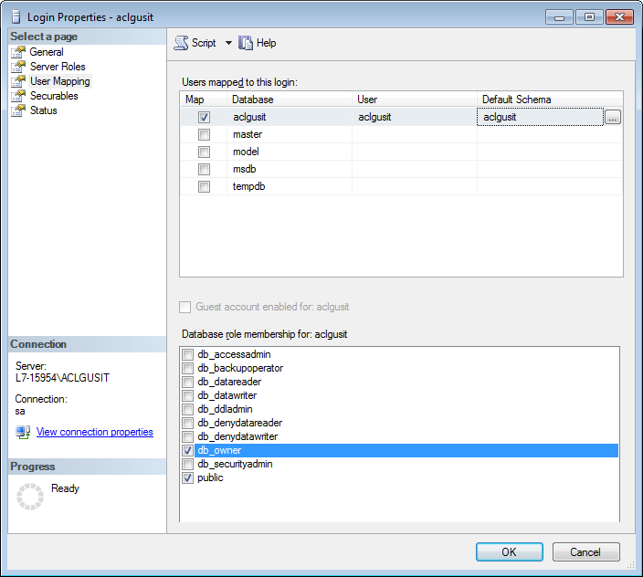
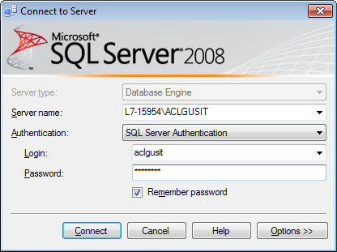

- Copy stored procedures manually from the source to the target logging in as “aclgusit”. A copy of them as of 2013/08/29 are in StoredProcedures.xlsx
Example:

CREATE Procedure [Attorney_Companies_Select](@AttorneyId int)

AS

SELECT * FROM COMPANY WHeRE AttorneyId=@AttorneyId order by Legal_Name

Option 2

To avoid missing identity column def

Step 1: Using Microsoft SQL Server Management Studio log in to the production database and export the table definitions:
Select the tables in the Object Explorer Details window on the right hand side and right click and select -> Script Table as -> CREATE To -> New Query Editor Window..
Copy the contents and execute in the local test database
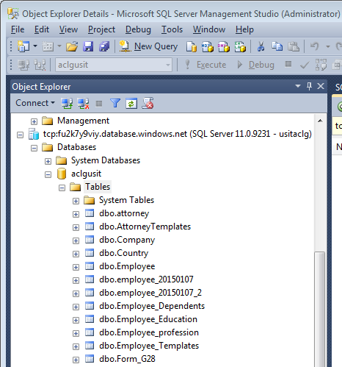

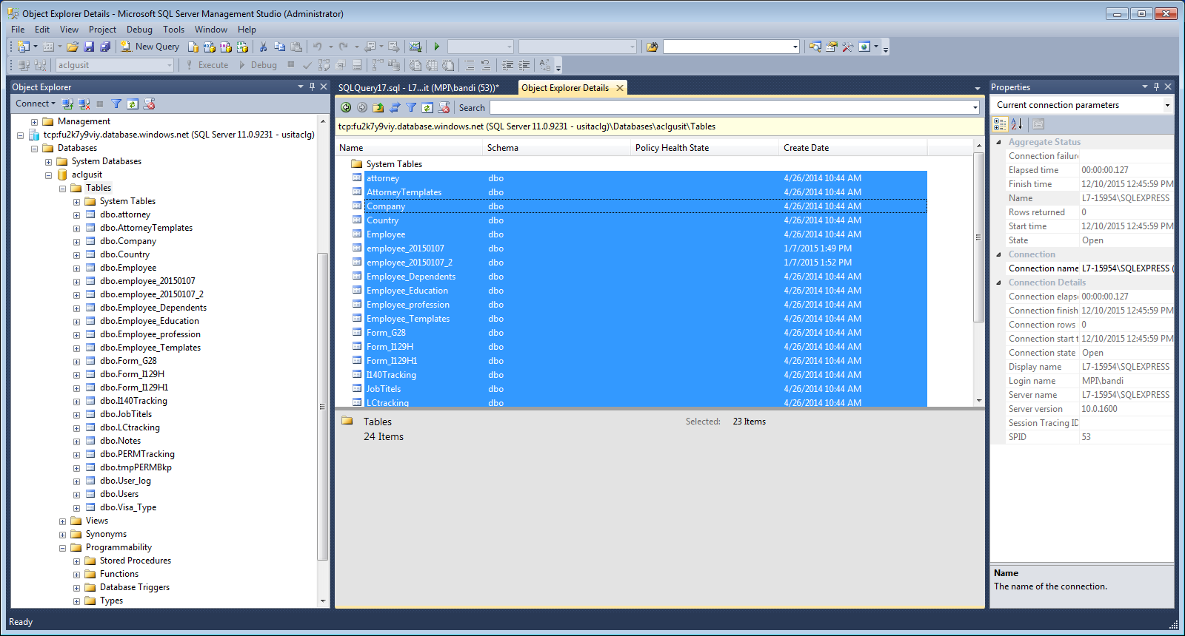

Step 2:
Use Import and Export Data tool in Microsoft sql server 2012 to import the data

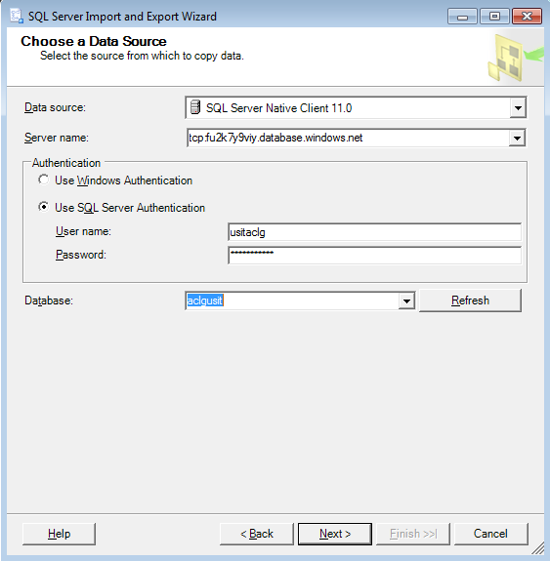

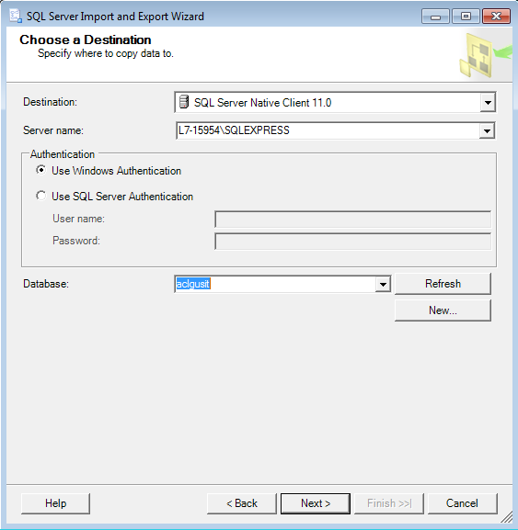

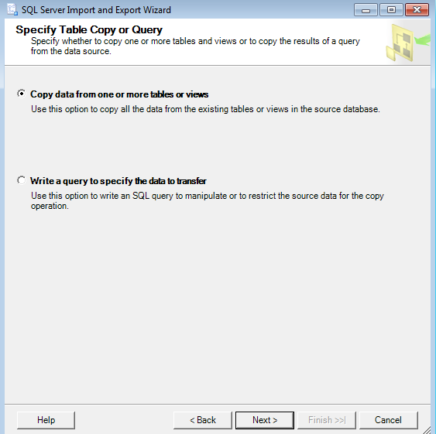

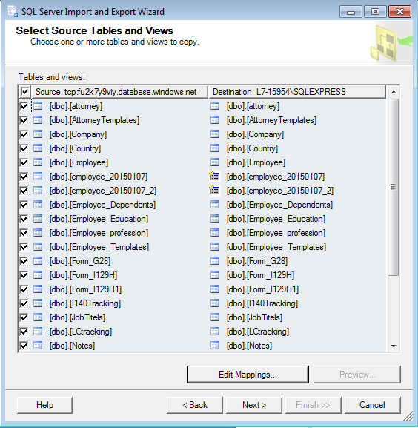

Click Edit Mappings

